IMPACT OF MULTICULTURAL ENVIRONMENT ON ORGANIZATIONAL PERFORMANCE OF XYZ COMPANY
Name:
ID No:

Introduction
Diversity is a major component in which leaders use to drive their organizations to achieve cultural inclusivity. In addition, diversity leadership is focused on the company’s work force to capitalize on diversity dynamics to achieve changes in the organizational performance. Further, diversity conscious leaders usually instill a mission that is related to a sense of identity so as to accomplish tremendous changes within their organizations. Moreover, these leaders usually manage work group processes so as to achieve a higher cultural impact for their organizations. This not only helps them to be successful but also improves their work performance. Moreover, these leaders are also keen in establishing professional and personal credibility through a code of conduct that enhances a diversified workforce (Sell & Chilpa, 2018). In a diversity conscious environment, leaders instill the principles of tolerance, multicultural relationships and also improved cross cultural communication.
Literature Review
Diversity leadership entails the application of processes that enhance techniques such as cohesion, trust, cooperation and communication within organization. A diversity conscious environment usually manages work place conflicts while at the same time enhancing how individuals relate to one another. A diversity conscious environment empowers subordinates in a micro environment. This not only helps the organization to improve on their performance but also improve many dynamics in the work force (Chin & Trimble, 2014).
Most of the analysis and factual information was gathered from the questionnaires that had been sent to the respondents and the results were then analyzed. The questions were centered on the issues related to diversity in the workplace, modes of communication and also cultural leadership. The questions were aimed at the examination of how employees perceive the modern day environment in relation to the cultural understanding. Consequently, in a multicultural organization, there is always a need to identify several concerns such as preparations, expectations, punctuality, leadership, reaching a consensus and also agenda. These help to deal with the common implications for the firm hence guide in the project organization and also helping the leadership to be successful. Consequently, the participants agreed on the need to engage the use of conflict resolution skills so as to deal with any emerging situations and challenges (Meredith & Mantel, 2017). Creating a cultural awareness is often a delicate balancing act that can guide project managers to deal with any emerging issues.
Section 1: Demographic Information
The participants who undertook the research were expatriates who have been working in a diversified environment. The ages of the participants ranged from 20 to 45 years. In addition, the participants were chosen randomly from the organization to be involved in this research process. A survey questionnaire was also used to question the participants about the research that involved the participants. The questions were based on attitudes towards diversity, cross cultural communication and also cooperate culture among the participants.
  - Job attitudes towards diversity and inclusion and cooperate culture
The first question on diversity and inclusivity in the workplace was based on the issue of whether employees are treated in a fair manner within the company. 70% of the respondents claimed at they strongly agreed that the company had adopted a code of conduct that ensured that employees were treated in a fair manner irrespective of their color, race or even social affiliation. A scale of 1 to 5 in which 1 was strongly disagree while 5 was strongly agree was considered for the research purposes. Additionally, creating a cultural awareness is often a delicate balancing act that can guide project managers to deal with any emerging issues.
In essence, one of the main challenges that are involved in cross cultural communication is to deal with social stereotypes, religious beliefs and also communication barriers (Chin & Trimble, 2014). The second question involves the respect of people from all cultures and backgrounds. Most of the participants agreed on the fact that most of the people come from different social backgrounds. 11.6 % agreed that they get along with each other, 26.5% of the 41 participants agreed they also got along with each other. Only 25.2% of the employees in the company disagreed on the fact of getting along with each other.
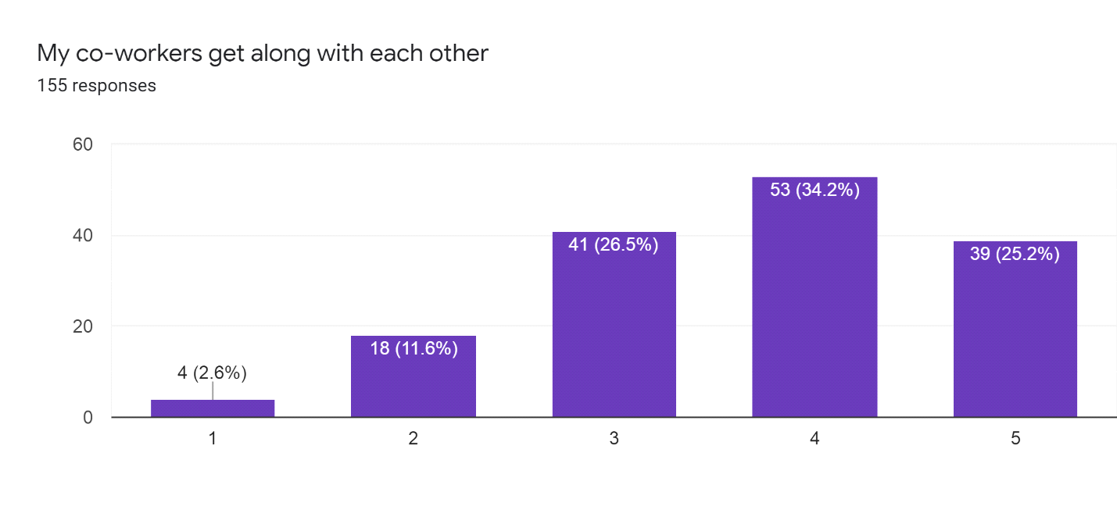

In addition, the participants also strongly agreed on the fact that the leadership of the firm strong enhanced diversity in the workforce and also improved inclusivity. This helped to engage the organization so as to know what happened over the years. Lastly, employees coming from different social affiliations and backgrounds interacted well within the firm (Sell & Chilpa, 2018).
1.2 Job Performance
A scale of 1 is 5 was used in the evaluation of Job performance. The first question was about the clarity of duties and job responsibilities. 70% of the employees strongly agreed that they were clear of the roles they perform in the workplace. XYZ firm strongly provides job allocations and roles to specific employees who have been subdivided into departments. This helps to provide all the employees with clarity of their positions and also responsibilities in the workplace. In addition, the company also provides for stronger feedback that ensures that every employee has performed their duty in an effective manner.30% of the employee’s greed on getting feedback from the company from the work they do. 50% of the employees agreed that they got rewards from their own job positions which helps to motivate them in their daily affairs in the workplace. 49% of the employees agreed that they can handle their work in a professional manner, which was a larger percentage in the company. Only 33 of the workers who represented 21.3% of the employees disagreed on the issue of effective job performance.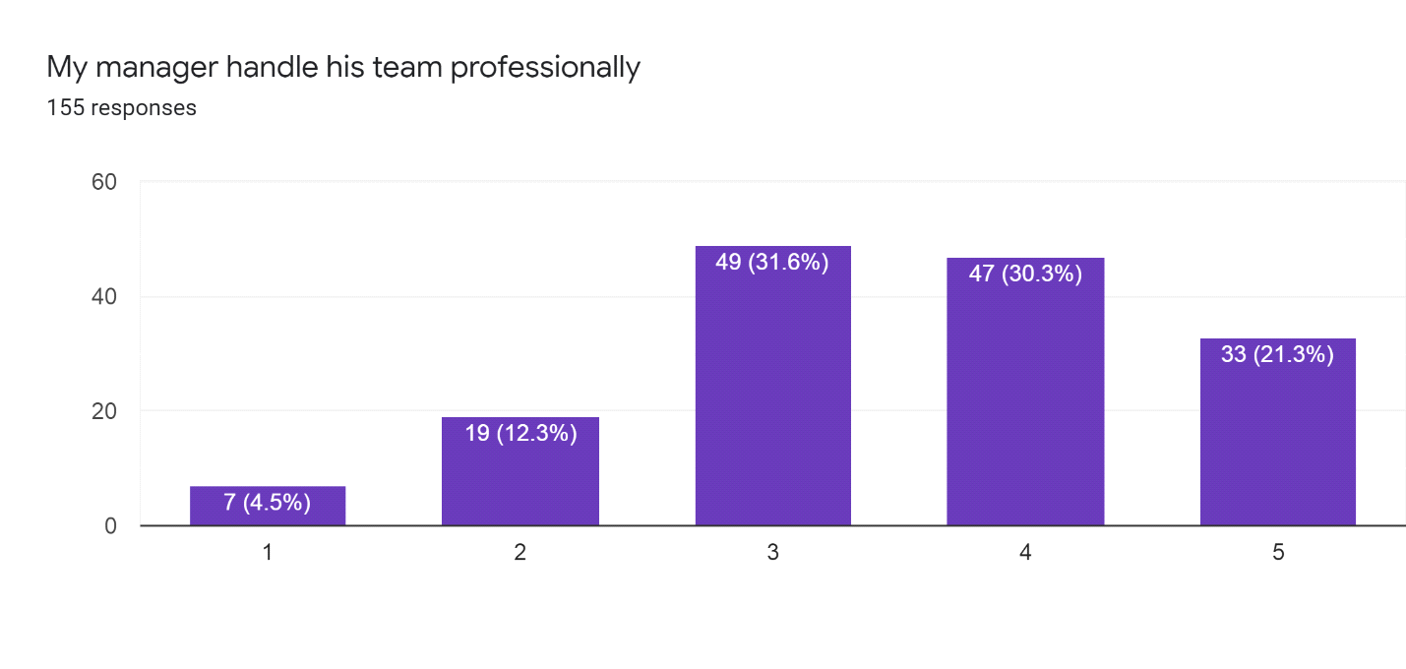

For a diverse organization to achieve success, it needs to provide its employees with some level of feedback. According to Chin and Trimble, (2014), since a cross functional team structure combines employees from several departments, it is evident that it brings people who work from different departments to improve the level of performance in the company. This helps the organization to achieve its objectives and also improve its skill performance. The cross functional structure would be helpful as it would improve the work flow and also lower any costs in the costs in the company. Most of the employee’s motivations are also improved while the layers of the management are generally expanded. This is because an employee from the sales department can be working simultaneously with the supervisor to ensure that the goals of the day have been achieved. A cross functional team structure is also self-directed and its structure is meant for the organization to make strong operational, tactical and also strategic goals that ensure that the organization has accomplished its goals. This is helpful in ensuring that the corporate goals and objectives have been attained in the larger scope of the organization (Meredith & Mantel, 2017).
The job performance in a successful organization should be designed in a manner that it promotes the general welfare of the employees. The business design should have a highly interactive process in which decisions are carried out in an effective manner hence helping the organization to achieve its key objectives. The growth of emerging markets would require the business to be designed in a manner in which its presence could be felt among the business stakeholders. The business design can be significant in transforming the culture of the organization and ensuring that every individual has become competent. In addition, the business leadership needs to encourage the employees to have a culture of tolerance and inclusivity in the workplace. A culture of inclusivity ensures that employees have acted in a socially acceptable manner. Since there are many conflicting opinions about ones actions and decisions, there is always a need to have a balance between ethical standards and the practices that one has in the society. Thus, it is clear that those are the major factors that enhance organizational performance while at the same time improving success over time (Lewis, 2018).
1.3 Leadership styles
A scale of 1 is to 5 was also used in the evaluation of leadership styles in the firm. 90% of the participants agreed that the leadership style in the firm provides them with assistance in their exchange efforts. Leadership was also found to be accountable in spending time to coaching and also in the teaching of employees. This helped to diversify the organization and also improve on its organizational performance. In addition, it was clear that the organization claimed that every employee was respected by the leadership. 80% of the employee’s ae also agreed that the leadership considered ethical and moral consequences in their decision making processes. This is due to the fact that most of the employees were found to have been involved in activities that improved their moral performances (Meredith & Mantel, 2017).
In leadership performance, it is clear that an organizational leadership should establish policies that ensure that there is a code of conduct among the subordinates. High levels of engagement and also communication between the leader and the subordinates is essential for improvement of engagement within the organization. Strong leadership usually encourages interpersonal relationships among the employees. This is due to the fat that strong relationships from the leadership can help to identify any emerging crisis between the management and the leadership. There is always a need to maintain high levels of openness and also honesty in the organization so as to improve how the organization performs to achieve its desired success (Meredith & Mantel, 2017).
The leader, who in most cases is usually the supervisor, is given the goal of ensuring that the organization has contributed towards the success of every individual. This ensures that the management has contributed towards the performance of the whole organization in the accomplishment of the specific goals and tasks. It is evident that as the company grows into other regions, there would be a need to establish a structure that helps it to accomplish its tasks and goals hence achieving the mission of the company In addition, a cross functional team structure, the team leader would have the power to combine various skills from the sales, administrative assistances and also management to ensure that objectives have been completed. Therefore, since the team leader cannot provide absolute directions and decisions, this improves the level of motivation among team members hence improving the process in which goals are accomplished in the organization (Meredith & Mantel, 2017).
1.4 Job satisfaction
A scale of 1 is to 5 was also used in the evaluation of Job satisfaction in the firm. There is always a need to address those challenges by identifying new ways to deal with the problems that arise in the new departments. The disruptions, trauma and also communication between the administrative centers and also the managers is a major issue that needs to be established. More than 70% of the employees agreed that there is a need to establish cultural understanding and trust so as promote equal cultural diversity, eliminate stereotypes and also engage other individuals in improved communication. This will help to engage everyone doing the projects so as to ensure that they have achieved effective languages and also educational programs. Maintenance of open communications and also engagement of key leaders is an important factor that would improve any form of conflict rising as a result of stereotypes.
On job participation, the graph was as follows.
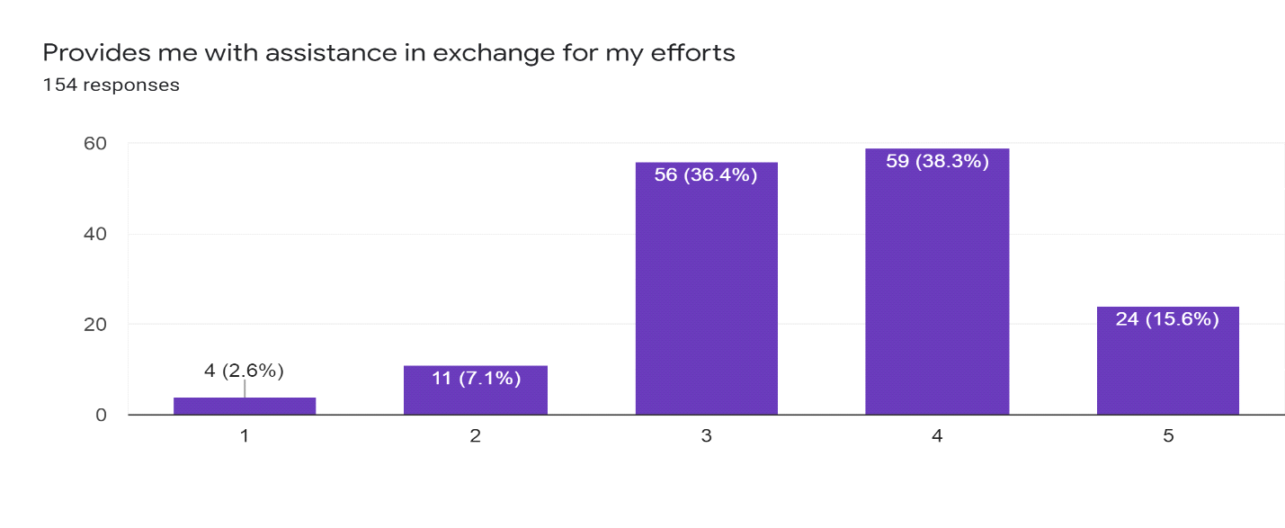
Indeed, this is because it improves the level of cooperation and competitiveness hence driving the success in achievement of laid out objectives. It is clearly that 56% of the employees agreed that they agreed with the coaching activities in the organization. In the cross functional team structure, the organization would be made up of teams in every department. All the teams shall work towards a common goal of ensuring the organization functions towards a specific objective. Moreover, the main reason for recommending a team structure is to ensure that the organization is focused towards a common objective of ensuring that everyone is held accountable for what they have contributed towards accomplishment of goals and specific objectives. Team structures are effective since they usually work towards a common objective and also towards accomplishment of specific tasks in the organization. In a team structure, the power of the organization is delegated towards the team to empower them to conduct their tasks
1.5 Improving cross cultural performance
In order to improve how the organization performs, there is a need to frame the personality characteristics of employees. Managers who communicate in a diverse business environment, need to have different levels of communicating with their employees. Most of the researchers use different methods and strategies for studying personality. The three most common methods are true experiments, experimental designs and correlational designs. Each of the methods use in the case studies has its own advantages and disadvantages. According to Lewis (2018), while defining personality can be considered to be a difficult process, the identification of these methods is helpful to assist individuals understand unique personalities as they have been exhibited by the society.
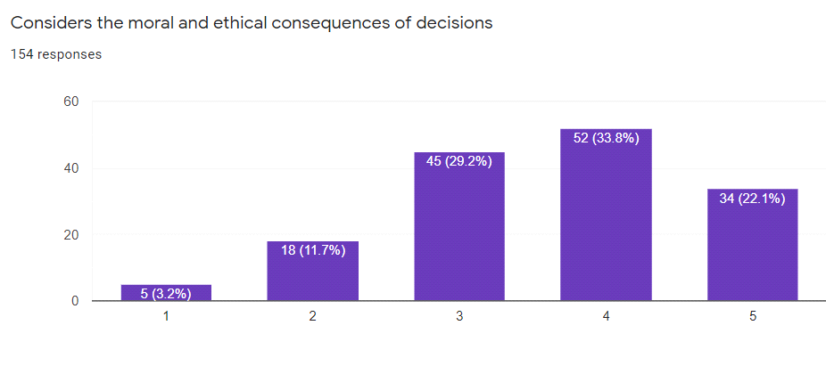
11.7% of the participants agreed on the moral consequences and also the ethical policies in the organization which was a representative of the 100% of the employees. 52 workers which represented 33.8% of the employees displayed how employees performed, which was a significant impact to the organizational performance. There are different reasons why researchers can decide to use one correlational approach to instead of using an experiment. For instance, in cases where they want to examine the validity of the research, they may consider using this kind of approach to test the participants (Meredith & Mantel, 2017). Another important thing learned from the study is that perceived choice can always help individuals to change their behaviors and attitudes on a particular subject. The manipulation of the choice over performing a task or an assessment of the perceived choice can always change the behavior of an individual. This can help to improve the cultural performance of the organization by ensuring that cross cultural awareness has been cultivated.
Conclusion
To sum it up, establishing multicultural communication in the workplace is one of those strategies that help to enhance diversity and improve the welfare of employees. Organizations need to establish a code of conduct that ensures that the employees have communicated with each other in a diverse manner. This not only helps to empower the employees but also encourages them to grow without any level of discrimination. Also, Employee tolerance and appreciation of diversities will help to improve the welfare of the company hence make employees to interact with each other. In addition, Lack of mutual understanding of cultural differences and values between expatriates and the locals. There is a need to improve multicultural engagement so as to prevent any escalation of conflicts, which in turn lead to disagreements for the people. For the company to overcome the uncertain political climate the company needs to avoid any political concerns affecting the country. Additionally, the company should also engage in activities that promote the welfare of the people. The company should also plan to enhance engagement with the people so as to understand their values and preferences
References
Chin, J. L., & Trimble, J. E. (2014). Diversity and Leadership. Thousand Oaks: SAGE Publications
Lewis, J. P. (2018). Mastering project management: Applying advanced concepts to systems thinking, control & evaluation, resource allocation. New York: McGraw-Hill.
Meredith, J. R., & Mantel, S. J. (2017). Project management: A managerial approach. Hoboken, NJ: Wiley.
Sell, R. D., & Chilpa Project. (2018). literature as communication: The ChiLPA Project. Amsterdam: John Benjamins Publishers.

